Alternative Futures – Choosing a Thriving or Endangered Future
We have a choice. We can choose to stay on the current path of an endangered future. Or we can choose the path to a much better future. Given that we humans need to survive and want to thrive forever, the choice should be a surviving and thriving future.
Alternative Future Scenarios. While there are many future scenarios, the focus here is on four: current, partial survive, partial thrive and full thrive. [See figure, “Alternative Futures for Human and Earth’s Surviving and Thriving”.] “Full Thrive Scenario” best fits our needs and wants but is the most challenging to achieve.
- Current Scenario - We continue our current path. As a result, 1) surviving and thriving are low and 2) surviving ends relatively soon. Compared to what we should be, too much of our world will be performing poorly or badly, poor (financially), poorly nourished, poorly housed, poorly protected (exposures, crime), poorly educated, physically/mentally ill, poorly growing/developing, not doing well “physically”, living within poor or bad habitat, excessively vulnerable, unstable and destructive climate, and not sustainable.
- Survive Scenario – We change to “survive” path. As a result, 1) thriving is low and 2) surviving is extended beyond current path. Compared to what we should be, too much of our world will continue to be performing poorly or badly, poor (financially), poorly nourished, poorly housed, poorly protected (exposures, crime), poorly educated, physically/mentally ill, poorly growing/developing, not doing well “physically”, living within poor or bad habitat, excessively vulnerable, unstable and destructive climate, and not sustainable.
- Partial Thrive Scenario – We change to a “partial thrive” path. As a result, 1) there is more thriving and 2) surviving is extended beyond current path. Compared to our current path, more are performing well, well-off (financially), well nourished, well housed, well protected (exposures, crime), well educated, physically and mentally well (people), growing/developing well, living within good habitat, physically well (Earth, plants, animals, environment), not vulnerable, producing personal and public goods, living within a stable, positive climate, and sustained.
- Full Thrive Scenario – We change to a “full thrive” path. As a result, 1) thriving is high and 2) surviving and thriving are extended substantially beyond current path and may continue at least as long as a habitable Earth lasts. All will be performing well, well-off (financially), well nourished, well housed, well protected (exposures, crime), well educated, physically and mentally well (people), growing/developing well, living within good habitat, physically well (Earth, plants, animals, environment), not vulnerable, producing personal and public goods, living within a stable, positive climate, and sustained.
To truly have this future, we need to have it for you and everybody’s family and friends and every community and every country and every part of and our entire world.
For the Full Thrive Scenario, all of us together must energize and empower people to build a thriving future for all. All of us together is necessary due to 1) the scope (all), 2) the level (surviving and thriving), and 3) the duration (forever).
When successful, we and all future generations achieve the thriving future for all forever, to the maximum extent possible. At this time in human history when we want to thrive, when we need to survive, when our future is most endangered, and when we are most capable, all of us together can and must build, achieve and sustain this future for all forever. This is the Thrive! Endeavor. www.ThriveEndeavor.org
Gary “Chris” Christopherson, Founder, Thrive!

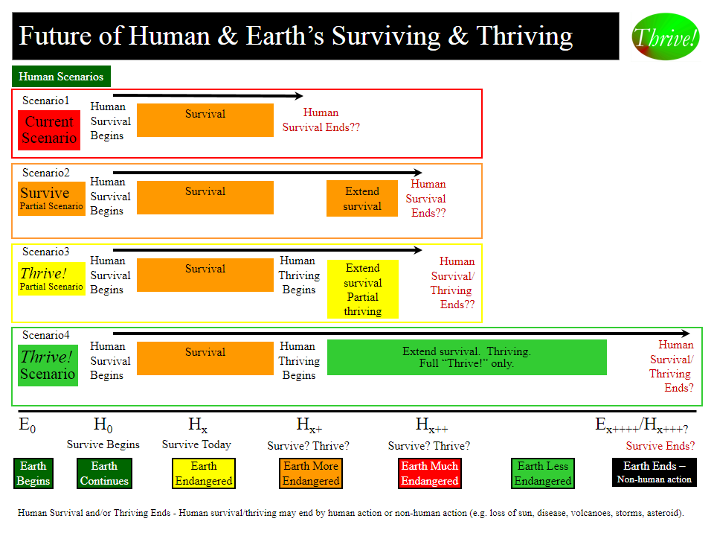
Alternative Futures – Choosing a Thriving or Endangered Future
We have a choice. We can choose the current path of an endangered future or choose the path to a much better future. Given that we humans need to survive and want to thrive forever, the choice should be a surviving and thriving future.
Alternative Future Scenarios. While there are many future scenarios, the focus here is on four: current, partial survive, partial thrive and full thrive. [See figure, “Alternative Futures for Human and Earth’s Surviving and Thriving”.] “Full Thrive Scenario” best fits our needs and wants but is the most challenging to achieve.
- Current Scenario - As a result, 1) surviving and thriving are low and 2) surviving ends relatively soon. Compared to what should be, too much of our world will be performing poorly or badly, poor (financially), poorly nourished, poorly housed, poorly protected (exposures, crime), poorly educated, physically/mentally ill, poorly growing/developing, not doing well “physically”, living within poor or bad habitat, excessively vulnerable, unstable and destructive climate, and not sustainable.
- Survive Scenario – As a result, 1) thriving is low and 2) surviving is extended beyond current path. Compared to what should be, too much of our world will continue as under the current scenario.
- Partial Thrive Scenario – As a result, 1) there is more thriving and 2) surviving is extended beyond current path. Compared to what should be, not enough of our world will be thriving.
- Full Thrive Scenario – As a result, 1) thriving is high and 2) surviving and thriving are extended substantially beyond current path and may continue at least as long as a habitable Earth lasts. All will be performing well, well-off (financially), well nourished, well housed, well protected (exposures, crime), well educated, physically and mentally well (people), growing/developing well, living within good habitat, physically well (Earth, plants, animals, environment), not vulnerable, producing personal and public goods, living within a stable, positive climate, and sustained.
To truly have this future, we need to have it for you and everybody’s family and friends and every community and every country and every part of and our entire world.
For the Full Thrive Scenario, all of us together must energize and empower people to build a thriving future for all. This is necessary due to 1) the scope (all), 2) the level (thriving), and 3) the duration (forever).
When successful, we and all future generations achieve the thriving future for all forever, to the maximum extent possible. At this time in human history when we want to thrive, when we need to survive, when our future is most endangered, and when we are most capable, all of us together can and must build, achieve and sustain this future for all forever. This is the Thrive! Endeavor. www.ThriveEndeavor.org

